Unit 1. Overview of Software development methodology and software quality model, different models of software development and their issues. Introduction to software architecture, evolution of software
architecture, software components and connectors, common software architecture frameworks,

Architecture business cycle – architectural patterns – reference model.

------------------------------------------------------------------------------------------------------------------------------------------------------

Software Architecture Definition:-
Software architecture is, simply, the organization of a system. This organization includes all components, how they interact with each other, the environment in which they operate, and the principles used to design the software. In many cases, it can also include the evolution of the software into the future.
Software architecture is designed with a specific mission or missions in mind. That mission has to be accomplished without hindering the missions of other tools or devices. The behavior and structure of the software impact significant decisions, so they need to be appropriately rendered and built for the best possible results.
Overview of Software development methodology and software quality model:-
Developing high-quality and reliable software is a challenging task that demands a comprehensive and structured approach. Here comes to help the concept of the software development life cycle (SDLC).
It’s can be defined as a framework that software engineers’ team follows that enables them to develop applications meeting requirements and timeline and providing value to their users.
So, we’re going to discuss this process of software development and the various SDLC models that are employed by developers’ teams.

What Is SDLC? Understand the Software Development Life Cycle?
SDLC is a process followed for a software project, within a software organization. It consists of a detailed plan describing how to develop, maintain, replace and alter or enhance specific software. The life cycle defines a methodology for improving the quality of software and the overall development process.
The following figure is a graphical representation of the various stages of a typical SDLC.

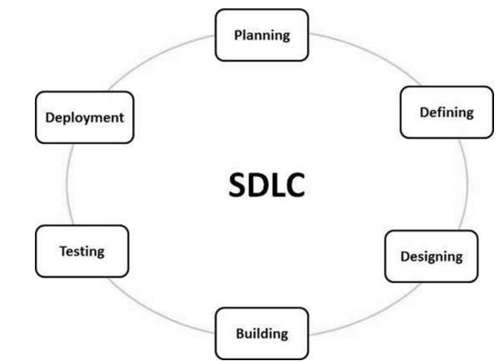

These 6 stages are discussed below.

- Stage-1: Planning And Requirement Analysis
- Stage-2: Defining Requirements
- Stage-3: Designing Architecture
- Stage-4: Developing Product
- Stage-5: Product Testing and Integration
- Stage 6: Deployment and Maintenance Of Product

Stage 1: Planning and Requirement Analysis
Requirement analysis is the most important and fundamental stage in SDLC. It is performed by the senior members of the team with inputs from the customer, the sales department, market surveys and domain experts in the industry. This information is then used to plan the basic project approach and to conduct product feasibility study in the economical, operational and technical areas.
Planning for the quality assurance requirements and identification of the risks associated with the project is also done in the planning stage. The outcome of the technical feasibility study is to define the various technical approaches that can be followed to implement the project successfully with minimum risks.

Stage 2: Defining Requirements
Once the requirement analysis is done the next step is to clearly define and document the product requirements and get them approved from the customer or the market analysts. This is done through an SRS (Software Requirement Specification) document which consists of all the product requirements to be designed and developed during the project life cycle.

Stage 3: Designing the Product Architecture
SRS is the reference for product architects to come out with the best architecture for the product to be developed. Based on the requirements specified in SRS, usually more than one design approach for the product architecture is proposed and documented in a DDS - Design Document Specification.
This DDS is reviewed by all the important stakeholders and based on various parameters as risk assessment, product robustness, design modularity, budget and time constraints, the best design approach is selected for the product.
A design approach clearly defines all the architectural modules of the product along with its communication and data flow representation with the external and third party modules (if any). The internal design of all the modules of the proposed architecture should be clearly defined with the minutest of the details in DDS.

Stage 4: Building or Developing the Product
In this stage of SDLC the actual development starts and the product is built. The programming code is generated as per DDS during this stage. If the design is performed in a detailed and organized manner, code generation can be accomplished without much hassle.
Developers must follow the coding guidelines defined by their organization and programming tools like compilers, interpreters, debuggers, etc. are used to generate the code. Different high level programming languages such as C, C++, Pascal, Java and PHP are used for coding. The programming language is chosen with respect to the type of software being developed.

Stage 5: Testing the Product
This stage is usually a subset of all the stages as in the modern SDLC models, the testing activities are mostly involved in all the stages of SDLC. However, this stage refers to the testing only stage of the product where product defects are reported, tracked, fixed and retested, until the product reaches the quality standards defined in the SRS.

Stage 6: Deployment in the Market and Maintenance
Once the product is tested and ready to be deployed it is released formally in the appropriate market. Sometimes product deployment happens in stages as per the business strategy of that organization. The product may first be released in a limited segment and tested in the real business environment (UAT- User acceptance testing).
Then based on the feedback, the product may be released as it is or with suggested enhancements in the targeting market segment. After the product is released in the market, its maintenance is done for the existing customer base.

Details of SDLC approach or SDLC Models
There are various software development life cycle models defined and designed which are followed during the software development process. These models are also referred as Software Development Process Models". Each process model follows a Series of steps unique to its type to ensure success in the process of software development.
Following are the most important and popular SDLC models followed in the industry −
- Waterfall Model
- Iterative Model
- Spiral Model
- V-Model
- Big Bang Model
Other related methodologies are Agile Model, RAD Model, Rapid Application Development and Prototyping Models.
The Waterfall Model was the first Process Model to be introduced. It is also referred to as a linear-sequential life cycle model. It is very simple to understand and use. In a waterfall model, each phase must be completed before the next phase can begin and there is no overlapping in the phases.
The Waterfall model is the earliest SDLC approach that was used for software development.
The waterfall Model illustrates the software development process in a linear sequential flow. This means that any phase in the development process begins only if the previous phase is complete. In this waterfall model, the phases do not overlap.

Waterfall Model - Design
Waterfall approach was first SDLC Model to be used widely in Software Engineering to ensure success of the project. In "The Waterfall" approach, the whole process of software development is divided into separate phases. In this Waterfall model, typically, the outcome of one phase acts as the input for the next phase sequentially.
The following illustration is a representation of the different phases of the Waterfall Model.
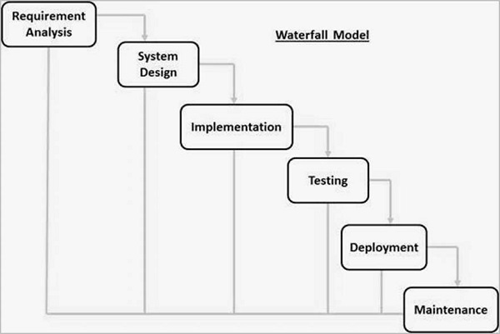
The sequential phases in Waterfall model are −
- Requirement Gathering and analysis − All possible requirements of the system to be developed are captured in this phase and documented in a requirement specification document.
- System Design − The requirement specifications from first phase are studied in this phase and the system design is prepared. This system design helps in specifying hardware and system requirements and helps in defining the overall system architecture.
- Implementation − With inputs from the system design, the system is first developed in small programs called units, which are integrated in the next phase. Each unit is developed and tested for its functionality, which is referred to as Unit Testing.
- Integration and Testing − All the units developed in the implementation phase are integrated into a system after testing of each unit. Post integration the entire system is tested for any faults and failures.
- Deployment of system − Once the functional and non-functional testing is done; the product is deployed in the customer environment or released into the market.
- Maintenance − There are some issues which come up in the client environment. To fix those issues, patches are released. Also to enhance the product some better versions are released. Maintenance is done to deliver these changes in the customer environment.
All these phases are cascaded to each other in which progress is seen as flowing steadily downwards (like a waterfall) through the phases. The next phase is started only after the defined set of goals are achieved for previous phase and it is signed off, so the name "Waterfall Model". In this model, phases do not overlap.

Waterfall Model - Application
Every software developed is different and requires a suitable SDLC approach to be followed based on the internal and external factors. Some situations where the use of Waterfall model is most appropriate are −
- Requirements are very well documented, clear and fixed.
- Product definition is stable.
- Technology is understood and is not dynamic.
- There are no ambiguous requirements.
- Ample resources with required expertise are available to support the product.
- The project is short.

Waterfall Model - Advantages
The advantages of waterfall development are that it allows for departmentalization and control. A schedule can be set with deadlines for each stage of development and a product can proceed through the development process model phases one by one.
Development moves from concept, through design, implementation, testing, installation, troubleshooting, and ends up at operation and maintenance. Each phase of development proceeds in strict order.

Some of the major advantages of the Waterfall Model are as follows −
- Simple and easy to understand and use
- Easy to manage due to the rigidity of the model. Each phase has specific deliverables and a review process.
- Phases are processed and completed one at a time.
- Works well for smaller projects where requirements are very well understood.
- Clearly defined stages.
- Well understood milestones.
- Easy to arrange tasks.
- Process and results are well documented.

Waterfall Model - Disadvantages
The disadvantage of waterfall development is that it does not allow much reflection or revision. Once an application is in the testing stage, it is very difficult to go back and change something that was not well-documented or thought upon in the concept stage.
The major disadvantages of the Waterfall Model are as follows −
- No working software is produced until late during the life cycle.
- High amounts of risk and uncertainty.
- Not a good model for complex and object-oriented projects.
- Poor model for long and ongoing projects.
- Not suitable for the projects where requirements are at a moderate to high risk of changing. So, risk and uncertainty is high with this process model.
- It is difficult to measure progress within stages.
- Cannot accommodate changing requirements.
- Adjusting scope during the life cycle can end a project.
- Integration is done as a "big-bang. at the very end, which doesn't allow identifying any technological or business bottleneck or challenges early.

2- SDLC - Iterative Model
In the Iterative model, iterative process starts with a simple implementation of a small set of the software requirements and iteratively enhances the evolving versions until the complete system is implemented and ready to be deployed.
An iterative life cycle model does not attempt to start with a full specification of requirements. Instead, development begins by specifying and implementing just part of the software, which is then reviewed to identify further requirements. This process is then repeated, producing a new version of the software at the end of each iteration of the model.

Iterative Model - Design
Iterative process starts with a simple implementation of a subset of the software requirements and iteratively enhances the evolving versions until the full system is implemented. At each iteration, design modifications are made and new functional capabilities are added. The basic idea behind this method is to develop a system through repeated cycles (iterative) and in smaller portions at a time (incremental).
The following illustration is a representation of the Iterative and Incremental model −
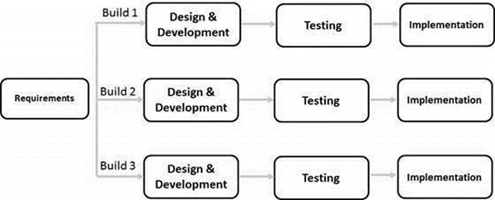
Iterative and Incremental development is a combination of both iterative design or iterative method and incremental build model for development. "During software development, more than one iteration of the software development cycle may be in progress at the same time." This process may be described as an "evolutionary acquisition" or "incremental build" approach."
In this incremental model, the whole requirement is divided into various builds. During each iteration, the development module goes through the requirements, design, implementation and testing phases. Each subsequent release of the module adds function to the previous release. The process continues till the complete system is ready as per the requirement.
The key to a successful use of an iterative software development lifecycle is rigorous validation of requirements, and verification & testing of each version of the software against those requirements within each cycle of the model. As the software evolves through successive cycles, tests must be repeated and extended to verify each version of the software.

Iterative Model - Application
Like other SDLC models, Iterative and incremental development has some specific applications in the software industry. This model is most often used in the following scenarios −
- Requirements of the complete system are clearly defined and understood.
- Major requirements must be defined; however, some functionalities or requested enhancements may evolve with time.
- There is a time to the market constraint.
- A new technology is being used and is being learnt by the development team while working on the project.
- Resources with needed skill sets are not available and are planned to be used on contract basis for specific iterations.
- There are some high-risk features and goals which may change in the future.

Iterative Model - Pros and Cons
The advantage of this model is that there is a working model of the system at a very early stage of development, which makes it easier to find functional or design flaws. Finding issues at an early stage of development enables to take corrective measures in a limited budget.
The disadvantage with this SDLC model is that it is applicable only to large and bulky software development projects. This is because it is hard to break a small software system into further small serviceable increments/modules.
The advantages of the Iterative and Incremental SDLC Model are as follows −
- Some working functionality can be developed quickly and early in the life cycle.
- Results are obtained early and periodically.
- Parallel development can be planned.
- Progress can be measured.
- Less costly to change the scope/requirements.
- Testing and debugging during smaller iteration is easy.
- Risks are identified and resolved during iteration; and each iteration is an easily managed milestone.
- Easier to manage risk - High risk part is done first.
- With every increment, operational product is delivered.
- Issues, challenges and risks identified from each increment can be utilized/applied to the next increment.
- Risk analysis is better.
- It supports changing requirements.
- Initial Operating time is less.
- Better suited for large and mission-critical projects.
- During the life cycle, software is produced early which facilitates customer evaluation and feedback.
The disadvantages of the Iterative and Incremental SDLC Model are as follows −
- More resources may be required.
- Although cost of change is lesser, but it is not very suitable for changing requirements.
- More management attention is required.
- System architecture or design issues may arise because not all requirements are gathered in the beginning of the entire life cycle.
- Defining increments may require definition of the complete system.
- Not suitable for smaller projects.
- Management complexity is more.
- End of project may not be known which is a risk.
- Highly skilled resources are required for risk analysis.
- Projects progress is highly dependent upon the risk analysis phase.

SDLC - Spiral Model
The spiral model combines the idea of iterative development with the systematic, controlled aspects of the waterfall model. This Spiral model is a combination of iterative development process model and sequential linear development model i.e. the waterfall model with a very high emphasis on risk analysis. It allows incremental releases of the product or incremental refinement through each iteration around the spiral.

Spiral Model - Design
The spiral model has four phases. A software project repeatedly passes through these phases in iterations called Spirals.

Identification
This phase starts with gathering the business requirements in the baseline spiral. In the subsequent spirals as the product matures, identification of system requirements, subsystem requirements and unit requirements are all done in this phase.
This phase also includes understanding the system requirements by continuous communication between the customer and the system analyst. At the end of the spiral, the product is deployed in the identified market.

Design
The Design phase starts with the conceptual design in the baseline spiral and involves architectural design, logical design of modules, physical product design and the final design in the subsequent spirals.

Construct or Build
The Construct phase refers to production of the actual software product at every spiral. In the baseline spiral, when the product is just thought of and the design is being developed a POC (Proof of Concept) is developed in this phase to get customer feedback.
Then in the subsequent spirals with higher clarity on requirements and design details a working model of the software called build is produced with a version number. These builds are sent to the customer for feedback.

Evaluation and Risk Analysis
Risk Analysis includes identifying, estimating and monitoring the technical feasibility and management risks, such as schedule slippage and cost overrun. After testing the build, at the end of first iteration, the customer evaluates the software and provides feedback.
The following illustration is a representation of the Spiral Model, listing the activities in each phase.
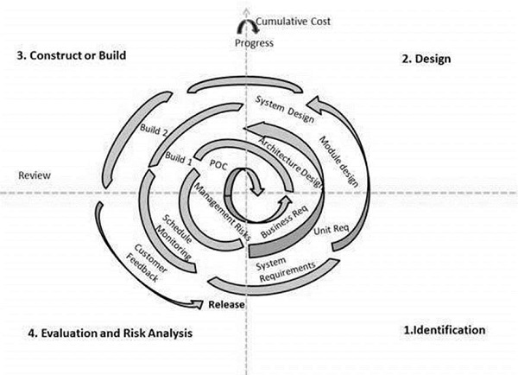
Based on the customer evaluation, the software development process enters the next iteration and subsequently follows the linear approach to implement the feedback suggested by the customer. The process of iterations along the spiral continues throughout the life of the software.

Spiral Model Application
The Spiral Model is widely used in the software industry as it is in sync with the natural development process of any product, i.e. learning with maturity which involves minimum risk for the customer as well as the development firms.
The following pointers explain the typical uses of a Spiral Model −
- When there is a budget constraint and risk evaluation is important.
- For medium to high-risk projects.
- Long-term project commitment because of potential changes to economic priorities as the requirements change with time.
- Customer is not sure of their requirements which is usually the case.
- Requirements are complex and need evaluation to get clarity.
- New product line which should be released in phases to get enough customer feedback.
- Significant changes are expected in the product during the development cycle.

Spiral Model - Pros and Cons
The advantage of spiral lifecycle model is that it allows elements of the product to be added in, when they become available or known. This assures that there is no conflict with previous requirements and design.
This method is consistent with approaches that have multiple software builds and releases which allows making an orderly transition to a maintenance activity. Another positive aspect of this method is that the spiral model forces an early user involvement in the system development effort.
On the other side, it takes a very strict management to complete such products and there is a risk of running the spiral in an indefinite loop. So, the discipline of change and the extent of taking change requests is very important to develop and deploy the product successfully.
The advantages of the Spiral SDLC Model are as follows −
- Changing requirements can be accommodated.
- Allows extensive use of prototypes.
- Requirements can be captured more accurately.
- Users see the system early.
- Development can be divided into smaller parts and the risky parts can be developed earlier which helps in better risk management.

The disadvantages of the Spiral SDLC Model are as follows −
- Management is more complex.
- End of the project may not be known early.
- Not suitable for small or low risk projects and could be expensive for small projects.
- Process is complex
- Spiral may go on indefinitely.
- Large number of intermediate stages requires excessive documentation.

SDLC - V-Model
The V-model is an SDLC model where execution of processes happens in a sequential manner in a V-shape. It is also known as Verification and Validation model.
The V-Model is an extension of the waterfall model and is based on the association of a testing phase for each corresponding development stage. This means that for every single phase in the development cycle, there is a directly associated testing phase. This is a highly-disciplined model and the next phase starts only after completion of the previous phase.

V-Model - Design
Under the V-Model, the corresponding testing phase of the development phase is planned in parallel. So, there are Verification phases on one side of the ‘V’ and Validation phases on the other side. The Coding Phase joins the two sides of the V-Model.

The following illustration depicts the different phases in a V-Model of the SDLC.
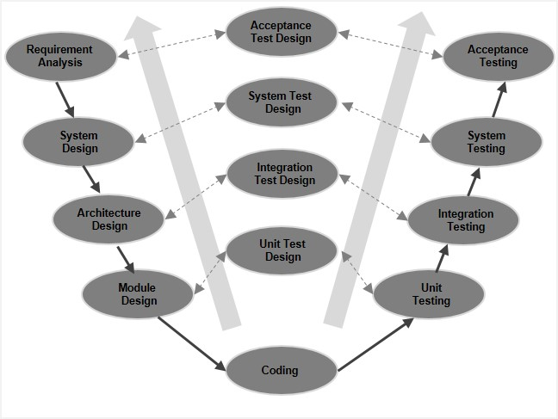

V-Model - Verification Phases
There are several Verification phases in the V-Model, each of these are explained in detail below.

Business Requirement Analysis
This is the first phase in the development cycle where the product requirements are understood from the customer’s perspective. This phase involves detailed communication with the customer to understand his expectations and exact requirement. This is a very important activity and needs to be managed well, as most of the customers are not sure about what exactly they need. The acceptance test design planning is done at this stage as business requirements can be used as an input for acceptance testing.

System Design
Once you have the clear and detailed product requirements, it is time to design the complete system. The system design will have the understanding and detailing the complete hardware and communication setup for the product under development. The system test plan is developed based on the system design. Doing this at an earlier stage leaves more time for the actual test execution later.

Architectural Design
Architectural specifications are understood and designed in this phase. Usually more than one technical approach is proposed and based on the technical and financial feasibility the final decision is taken. The system design is broken down further into modules taking up different functionality. This is also referred to as High Level Design (HLD).
The data transfer and communication between the internal modules and with the outside world (other systems) is clearly understood and defined in this stage. With this information, integration tests can be designed and documented during this stage.
Agile SDLC model
Agile SDLC model is a combination of iterative and incremental process models with focus on process adaptability and customer satisfaction by rapid delivery of working software product. Agile Methods break the product into small incremental builds. These builds are provided in iterations. Each iteration typically lasts from about one to three weeks. Every iteration involves cross functional teams working simultaneously on various areas like −
- Planning
- Requirements Analysis
- Design
- Coding
- Unit Testing and
- Acceptance Testing.
At the end of the iteration, a working product is displayed to the customer and important stakeholders.

What is Agile?
Agile model believes that every project needs to be handled differently and the existing methods need to be tailored to best suit the project requirements. In Agile, the tasks are divided to time boxes (small time frames) to deliver specific features for a release.
Iterative approach is taken and working software build is delivered after each iteration. Each build is incremental in terms of features; the final build holds all the features required by the customer.
Here is a graphical illustration of the Agile Model −
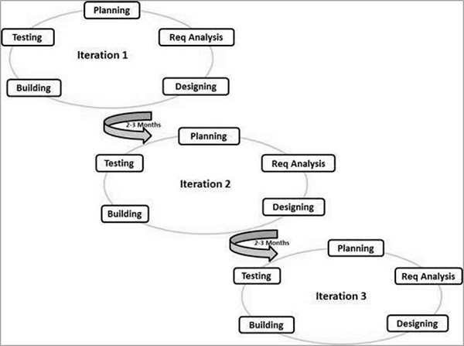
The Agile thought process had started early in the software development and started becoming popular with time due to its flexibility and adaptability.
The most popular Agile methods include Rational Unified Process (1994), Scrum (1995), Crystal Clear, Extreme Programming (1996), Adaptive Software Development, Feature Driven Development, and Dynamic Systems Development Method (DSDM) (1995). These are now collectively referred to as Agile Methodologies, after the Agile Manifesto was published in 2001.
Following are the Agile Manifesto principles −
- Individuals and interactions − In Agile development, self-organization and motivation are important, as are interactions like co-location and pair programming.
- Working software − Demo working software is considered the best means of communication with the customers to understand their requirements, instead of just depending on documentation.
- Customer collaboration − As the requirements cannot be gathered completely in the beginning of the project due to various factors, continuous customer interaction is very important to get proper product requirements.
- Responding to change − Agile Development is focused on quick responses to change and continuous development.

Agile Model - Pros and Cons
Agile methods are being widely accepted in the software world recently. However, this method may not always be suitable for all products. Here are some pros and cons of the Agile model.
The advantages of the Agile Model are as follows −
- Is a very realistic approach to software development.
- Promotes teamwork and cross training.
- Functionality can be developed rapidly and demonstrated.
- Resource requirements are minimum.
- Suitable for fixed or changing requirements
- Delivers early partial working solutions.
- Good model for environments that change steadily.
- Minimal rules, documentation easily employed.
- Enables concurrent development and delivery within an overall planned context.
- Little or no planning required.
- Easy to manage.
- Gives flexibility to developers.
The disadvantages of the Agile Model are as follows −
- Not suitable for handling complex dependencies.
- More risk of sustainability, maintainability and extensibility.
- An overall plan, an agile leader and agile PM practice is a must without which it will not work.
- Strict delivery management dictates the scope, functionality to be delivered, and adjustments to meet the deadlines.
- Depends heavily on customer interaction, so if customer is not clear, team can be driven in the wrong direction.
- There is a very high individual dependency, since there is minimum documentation generated.
- Transfer of technology to new team members may be quite challenging due to lack of documentation.
Big Bang Model
The Big Bang model is an SDLC model where we do not follow any specific process. The development just starts with the required money and efforts as the input, and the output is the software developed which may or may not be as per customer requirement. This Big Bang Model does not follow a process/procedure and there is a very little planning required. Even the customer is not sure about what exactly he wants and the requirements are implemented on the fly without much analysis.
Usually this model is followed for small projects where the development teams are very small.

Big Bang Model ─ Design and Application
The Big Bang Model comprises of focusing all the possible resources in the software development and coding, with very little or no planning. The requirements are understood and implemented as they come. Any changes required may or may not need to revamp the complete software.
This model is ideal for small projects with one or two developers working together and is also useful for academic or practice projects. It is an ideal model for the product where requirements are not well understood and the final release date is not given.

Big Bang Model - Pros and Cons
The advantage of this Big Bang Model is that it is very simple and requires very little or no planning. Easy to manage and no formal procedure are required.
However, the Big Bang Model is a very high risk model and changes in the requirements or misunderstood requirements may even lead to complete reversal or scraping of the project. It is ideal for repetitive or small projects with minimum risks.
The advantages of the Big Bang Model are as follows −
- This is a very simple model
- Little or no planning required
- Easy to manage
- Very few resources required
- Gives flexibility to developers
- It is a good learning aid for new comers or students.
The disadvantages of the Big Bang Model are as follows −
- Very High risk and uncertainty.
- Not a good model for complex and object-oriented projects.
- Poor model for long and ongoing projects.
- Can turn out to be very expensive if requirements are misunderstood.
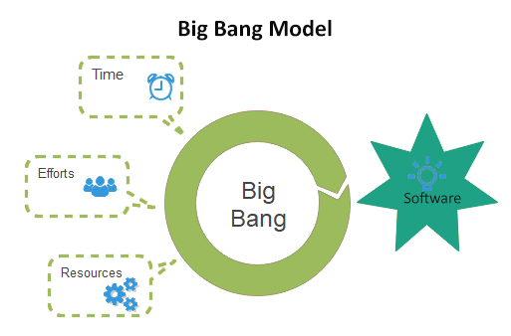
Component and Connector View:-
Introduction:- Component and Connector (C&C) architecture view of a system has two main elements—components and connectors. Components are usually computational elements or data stores that have some presence during the system execution. Connectors define the means of interaction between these components.
A C&C view of the system defines the components, and which component is connected to which and through what connector. A C&C view describes a runtime structure of the system—what components exist when the system is executing and how they interact during the execution. The C&C structure is essentially a graph, with components as nodes and connectors as edges. C&C view is perhaps the most common view of architecture and most box-and-line drawings representing architecture attempt to capture this view. Most often when people talk about the architecture, they refer to the C&C view. Most architecture description languages also focus on the C&C view.
Components:-Components are generally units of computation or data stores in the system. A component has a name, which is generally chosen to represent the role of the component or the function it performs.
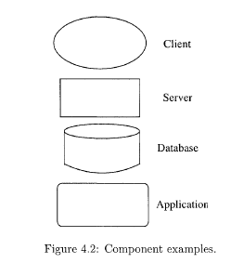
A component is of a component-type, where the type represents a generic component, defining the general computation and the interfaces a component of that type must have. Note that though a component has a type, in the C&C architecture view.
In a diagram representing a C&C architecture view of a system, it is highly desirable to have a different representation for different component types, so the different types can be identified visually. In a box-and-line diagram, often all components are represented as rectangular boxes. Such an approach will require that types of the components are described separately
and the reader has to read the description to figure out the types of the components. It is much better to use a different symbol/notation for each different component type. If there are multiple components of the same type, then each of these components will be represented using the same symbol they will be distinguished from each other by their names. Components use interfaces to communicate with other components. The interfaces are sometimes called ports. A component must clearly specify its the component in the supporting documents, as a C&C drawing will only show the component names.
It would be useful if there was a list of standard symbols that could be used to build an architecture diagram. However, as there is no standard list of component types, there is no such standard list.
As there are no standard notations for different component types and an architect can use his own symbols, the type information cannot be obtained by a reader from the symbols used. To make sure that the meanings of the different symbols is clear to the reader, it is therefore necessary to have a key of the different symbols to describe what type of component a symbol represents.
A component is essentially a system in its own right providing some behavior at defined interfaces (i.e., ports) to its environment. Like any system, a component may be complex and have a structure of its own, which can be determined by decomposing the component. In many situations, particularly for systems that are not too large, there may not be a need to decompose the components to determine their internal architecture.
Connectors: - The different components of a system are likely to interact while the system is in operation to provide the services expected of the system. After all, components exist to provide parts of the services and features of the system, and these must be combined to deliver the overall system functionality. For composing a system from its components, information about the interaction between components is necessary.
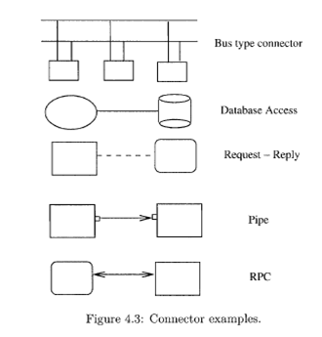
Interaction between components may be through a simple means supported by the underlying process execution infrastructure of the operating system. For example, a component may interact with another using the procedure call mechanism (a connector,) which is provided by the runtime environment for the programming language. However, the interaction may involve more complex mechanisms as well. Examples of such mechanisms are remote procedure call, TCP/IP ports, and a protocol like HTTP. These mechanisms require a fair amount of underlying runtime infrastructure, as well as special programming within the components to use the infrastructure.
Consequently, it is extremely important to identify and explicitly represent these connectors. Specification of connectors will help identify the suitable infrastructure needed to implement an architecture, as well as clarify the programming needs for components using them. Without a proper understanding of the connectors, a realization of the components using the connectors may not be possible.
Note that connectors need not be binary and a connector may provide a n-way communication between multiple components. For example, a broadcast bus may be used as a connector, which allows a component to broadcast its message to all the other components. (Of course, how such a connector will be implemented is another issue that must be resolved before the architecture can be implemented. Generally, while creating architecture, it is wise for the architect to use the connectors, which are available on the systems on which the software will be deployed. Otherwise, there must be plans to build those connectors, or buy them, if they are available.)
A connector also has a name that should describe the nature of interaction the connector supports. A connector also has a type, which is a generic description of the interaction, specifying properties like whether it is a binary or n-way, types of interfaces it supports, etc. Sometimes, the interaction supported by a connector is best represented as a protocol.
A protocol implies that when two or more components use the connector using the protocol to communicate, they must follow some conventions about order of events or commands, order in which data is to be grouped for sending, error condition set c. For example, if TCP ports are to be used to send information from one process to another (TCP ports are the connector between the two components of process type), the protocol requires that a connection must first be established and a port number obtained before sending the information, and that the connection should be closed in the end. A protocol description makes all these constraints explicit, and defines the error conditions and special scenarios. If a protocol is used by a connector type, it should be explicitly stated.
What is a software connector?
software connectors perform transfer of control and data among components. Connectors can also provide services, such as persistence, invocation, messaging and transactions, that are largely independent of the interacting components’ functionalities. These services are usually considered to be ‘facilities components’ in widely used middleware standards such as CORBA, DCOM and RMI.”

What is a software component?
The. Component/connector view is one fundamental view of a software architecture. The other two are the Module Decomposition View and the Allocation view.
A . Component is a unit of behavior. Its description defines what the component can do and what it requires to do that job.
A . Connector is an indication that there is a mechanism that relates one component to another usually through relationships such as data flow or control flow.
Changing the grouping of behaviors in components or changing which components are connected changes the value of certain quality attributes.
For "from scratch" design, this is usually the driving view.

Common Software Architecture Frameworks:-

Definition: An architecture framework is an encapsulation of a minimum set of practices and requirements for artifacts that describe a system's architecture. Models are representations of how objects in a system fit structurally in and behave as part of the system. Views are a partial expression of the system from a particular perspective. A viewpoint is a set of representations (views and models) of an architecture that covers a stakeholder's issues.
Keywords: architecture, architecture description, architecture frameworks, models, viewpoint, views.
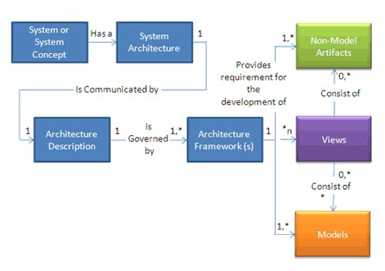
Figure 1. Architecture Framework, Models, and Views Relationship [1]

Architecture business cycle:-
“Architecture Business Cycle (ABC) is description of a system, used to represent relationship among structures/ components of the system to the environment in which the system is developed and implemented.”
The architecture of a system describes its major components, their relationships (structures), and how they interact with each other. Software architecture and design includes several contributory factors such as Business strategy, quality attributes, human dynamics, design, and IT environment.
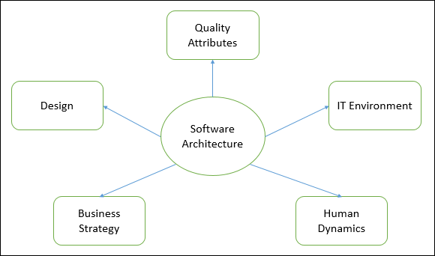
We can segregate Software Architecture and Design into two distinct phases: Software Architecture and Software Design.
In Architecture, nonfunctional decisions are cast and separated by the functional requirements.
In Design, functional requirements are accomplished.
Three things required for ABC are as follows:
i. Case studies of successful architectures crafted to satisfy demanding requirements, so as to help set the technical playing field of the day.
ii. Methods to assess architecture before any system are built from it, so as to mitigate the risks associated with launching unprecedented designs.
iii. Techniques for incremental architecture-based development, so as to uncover design flaws before it is too late to correct them.
1. An architectural pattern is a description of element and relation types together with a set of constraints on how they may be used. A pattern can be thought of as a set of constraints on architecture? on the element types and their patterns of interaction? and these constraints define a set or family of architectures that satisfy them. For example, client-server is a common architectural pattern. Client and server are two element types, and their coordination is described in terms of the protocol that the server uses to communicate with each of its clients. Use of the term client server implies only that multiple clients exist; the clients themselves are not identified, and there is no discussion of what functionality, other than implementation of the protocols, has been assigned to any of the clients or to the server. Countless architecture is of the client-server pattern under this (informal) definition, but they are different from each other. An architectural pattern is not architecture, then, but it still conveys a useful image of the system? It imposes useful constraints on the architecture and, in turn, on the system. One of the most useful aspects of patterns is that they exhibit known quality attributes. This is why the architect chooses a particular pattern and not one at random. Some patterns represent known solutions to performance problems, others lend themselves well to high-security systems, still others have been used successfully in high-availability systems. Choosing an architectural pattern is often the architect's first major design choice.
The term architectural style has also been widely used to describe the same concept.
2. A reference model is a division of functionality together with data flow between the pieces. A reference model is a standard decomposition of a known problem into parts that cooperatively solve the problem. Arising from experience, reference models are a characteristic of mature domains. Can you name the standard parts of a compiler or a database management system? Can you explain in broad terms how the parts work together to accomplish their collective purpose? If so, it is because you have been taught a reference model of these applications.

